Here’s Week 8 of PE at Home. A shout out picture was sent to me with Eliza and her sister who visited some horses to feed them. You can check out the picture and others on the DATL PE Website. www.leatherbarrowphysed.com. Pictures or drawings can be emailed to me at michelle.brenton@nbed.nb.ca. Please state if they may be published or not.
Next week, I’ll be sending 1 large activity to end our distance learning and to kick off summer – a VIRTUAL FIELD DAY!
Once again, none of these activities are mandatory – I’m happy to provide you a variety of ideas that can help with the recommended 30-minutes of daily physical activity. Stay well!
My Virtual Classroom | I’ll leave this here in case you didn’t get to visit last week or you want to try the activities again. Come visit me and click on a variety of objects to learn a new activity or practice one we’ve done before; there’s even a song and a story.  https://docs.google.com/presentation/d/1C9gw_zs3VbWOHY-SZPgSWC30bSv3nES_NEdg5eJXrQo/edit?usp=sharing
Move It Monday  Or let’s call it MAKE IT Monday for this week! | Did you know that #FitnessROCKS?????  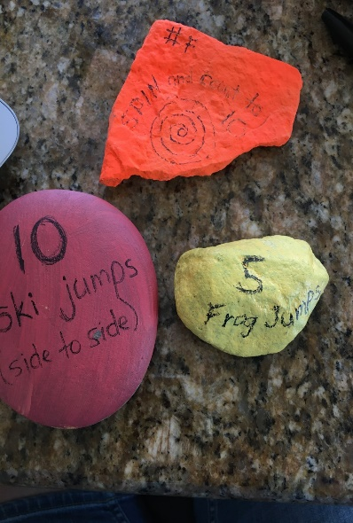  On your next hike, how about collecting a rock or two (flat is best) and painting an exercise on it? Take it back to the trail the next time you go. If lots of us do this, we’ll have an amazing fitness trail!! Examples – 5 jumping jacks, 10 squats, run to the next turn, skip to 20, make a zigzag path, jump side to side 10 times. Get creative! Acrylic paint is the best to use. When it’s dry, try some black paint or a thick Sharpie marker. Did you know that families at HES will also be doing this? Together, we can create an AWESOME fitness trail joining our two schools!!! I’d love to get some pictures of the rocks you paint! Here’s a sample of mine; orange is spray paint on a rough rock – didn’t really turn out. Red paint (looks pink in the picture) is on a very smooth rock with a thin Sharpie. The yellow one is acrylic with a thin Sharpie. If you’d like to label your rock, feel free to add your name and the hashtag #FitnessROCKS2020. Remember to physically distance yourself from others using the trail. Have fun! Next week, send me a pic of you participating in the FitnessROCKS fitness trail!!!
Try It Tuesday | Hallway Bowling  At the end of a hallway, set up paper or plastic cups, water bottles, empty milk cartons, etc. that kids can knock over. Use a soft ball or rolled up socks to roll toward the cups to knock them down.  Remember when you roll a ball, you bend your knees, swing your arm back, step with the opposite foot and roll the ball along the floor. Have a competition with a family member.  (Gr. K-2 could attach sight words (English or French), numbers for recognition, addition/subtraction sentences to solve, etc.)
Wellness Wednesday | With members in your household, create a cozy area in your home. Decide the location of the area (e.g., basement, living room corner, bedroom). What should be in it (e.g., blankets, pillows, stuffed animals, books, a flashlight)? What would it be used for (e.g., quiet time, calming down)? Are there rules? (e.g. no screens; healthy snacks only; no drinks; bring your own stuffie; colouring or reading or napping allowed, etc.). Make sure you include everyone.
This OR That Thursday | Follow the Leader One player, the leader, begins moving around the yard or indoor space with actions that the rest of the players must mimic. Anything — including wildly swing hands, jumping over rocks, crawling under branches, bird sound, bear walk…etc — that the leader does, the others must follow. Those players who cannot mimic, must do 10 jumping jacks. After 2-3 mins switch the leader.  OR  Pop! Pop! Pop! Blow bubbles and run around popping them. Count how many bubbles you can pop. Can you gallop, hop, jump, etc. and pop bubble? How many? See if you can pop the bubbles with your elbow, knee, nose, shoulder. etc.
Fitness Fun Friday | 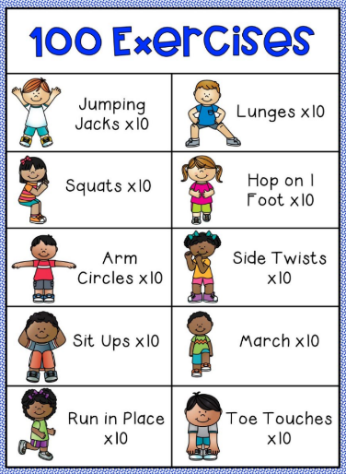  How long will it take you to complete 100 exercises??
On-line Anytime Activities | Body Boogie with The Learning Station  https://www.youtube.com/watch?v=cZeM18fPbvI
All Month Long | Check out the June ASD-S Physical Activity calendar which is posted at www.leatherbarrowphysed.weebly.com

