Welcome to week 3 of PE at Home! The weather certainly has improved which makes it much easier to get outside. Big thanks to Caleb who sent me a picture of himself doing some of last week’s Toss & Catch Challenges! I’ve posted his picture on my website gallery page. Pictures or drawings can be sent to me at michelle.brenton@nbed.nb.ca ; let me know if I am able to post it in the gallery on my website. I’d love to see how your children are staying active & healthy and the creative ways they are having fun – maybe your child will get a “shout out” in next week’s newsletter! Once again, you are not expected to complete everything. Choose activities that your children enjoy or are interested in trying. Have fun being active together! 😊
Move It Monday | 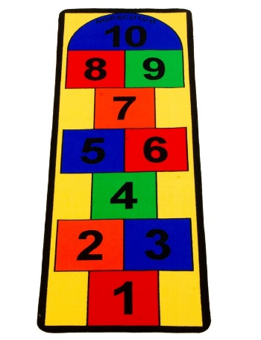  Can you find some pavement somewhere and draw a hopscotch pattern with chalk? Use a small toy, beanbag if you have one, or a stone as your tossing item (something that won’t roll). Teach someone in your family to play; you can watch this for a refresher on the rules of the game: https://youtu.be/SeN9wQCEsqk  You can also try some of these hopscotch challenges. https://youtu.be/kyc88lLnQaY
Try It Tuesday | Using household items, sports equipment, recycling items, etc around your house, build an obstacle course either inside or outside. Ideas for inside might include crawling under a table or chairs, going up and down a staircase, rolling down a hallway, zigzagging around a line of small toys or plastic bottles, tossing and catching a scarf, stepping or jumping over shoes, etc. If you create one outside, use items already there: trees to zig zag around, rocks to step on (hot lava!), sticks to jump over, and add in a few exercises along the way like jumping jacks, plank for 10 seconds, walking lunges, etc. Be creative and have fun! How long does it take you to complete your course?
Wellness Wednesday | Balance means many things to many people. In PE class, we talk about and practice balancing on different parts of our bodies, but we also talk about taking time to quiet our bodies and minds. Try the balances on the chart below (3rd page). You’ll need a die.  When your brain and body need a rest, take a couple of minutes to practice some deep breathing with this cute blowfish!! It’s soooooo relaxing!https://youtu.be/gLbK0o9Bk7Q
This OR That Thursday | Make your own Jump Rope from plastic bags (18 plastic bags, scissors and duct tape) (Mom or Dad can help: https://youtu.be/zmRNNqXJaKk OR  Bowling Challenges: You need an object to roll: tennis or other small ball, ball of socks, etc and some targets.  Remember our underhand rolling cues:  - Eyes on the target.  - Swing throwing arm backwards.  - Step with opposite foot.  - Get low.  - Let it go! Point to the target (follow through)  1. Start 3 giant steps away from your target. Bowl until you hit your target 3 times in a row. Then move backwards another big step. Keep your form even though you’re farther away.  2. Try bowling with your opposite hand!  3. Put an obstacle (like a chair) in the way so you have to bowl underneath it and still hit your target.
Fitness Fun Friday | 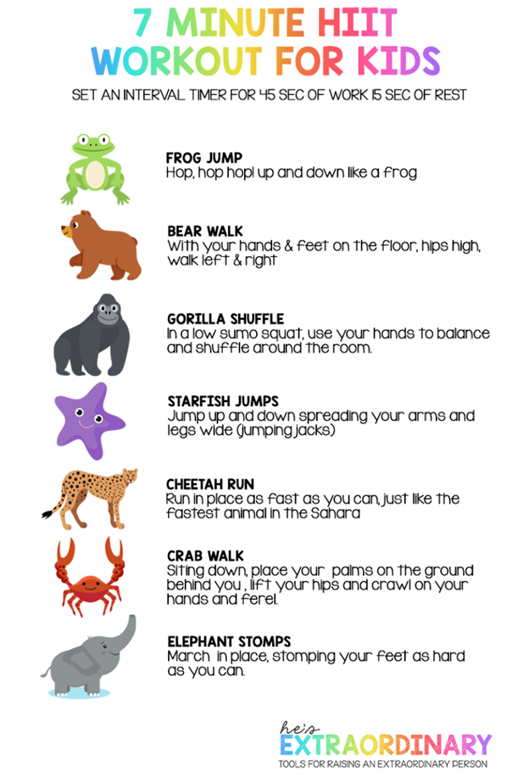  Are there other animals you like to imitate and move like?
On-line Anytime Activities | Coach Meger Tabata Fitness Workout  https://youtu.be/FMRhCR0M3gg  Jack Hartmann Alphabet Exercise  https://youtu.be/SE-ljfAmZis  Website of the Week: www.gonoodle.com

Roll – A – Pose
Roll 1 die, and then choose a pose in the column underneath your number. Can you hold the pose still for 5 seconds? 10 seconds?
Challenge a family member to a ‘who can hold the longest’ contest.
 | 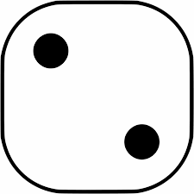 | 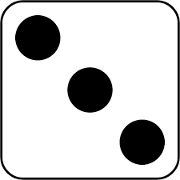 | 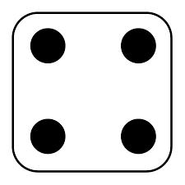 | 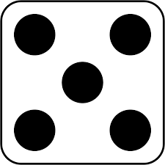 | 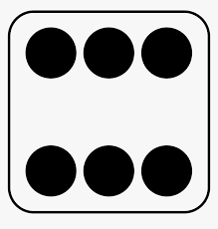
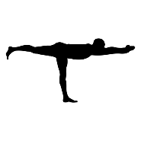 | 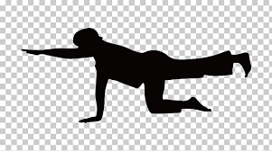 | 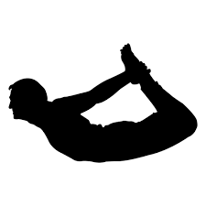 | 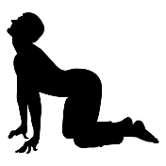 | 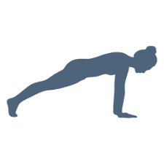 | 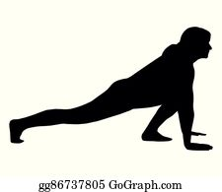
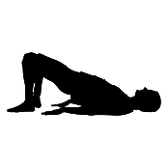 | 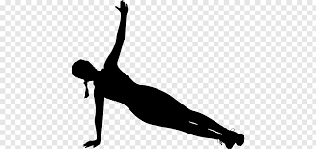 | 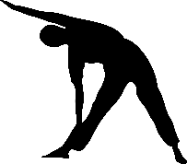 | 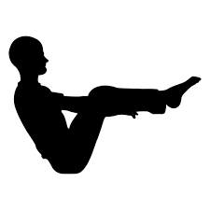 |  | 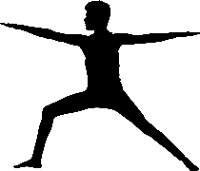
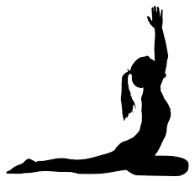 | 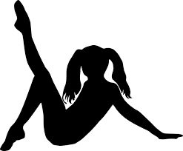 | 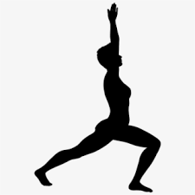 | 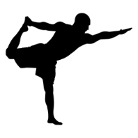 | 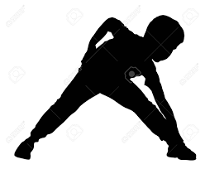 | 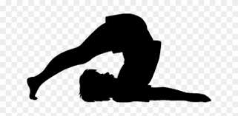
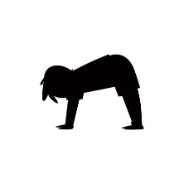 | 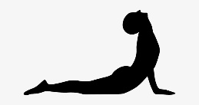 | 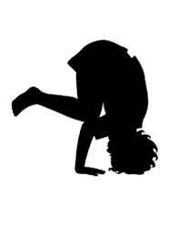 | 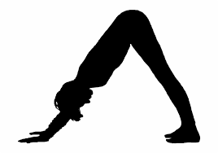 | 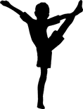 | 