Welcome to our first newsletter!

GETTING OUTSIDE – dress for the weather!

***What you need***: a copy of Spring Thaw BINGO (next page) and a crayon to mark or a sticker to place on each square or you can play digitally from a phone. You could also draw your own BINGO grid if you don’t have a printer.

***What to do***: dress appropriately and head outside with your family. Aim for 20-30 minutes for each walk and see how many items you can find.

***Create***: Can you make a list of other things to find outside next time?

***Locomotor Speedway***

Locomotor movements are ways in which the body travels through space from one location to another. The 6 common locomotor movements are walking, running, skipping, galloping, hopping, and jumping.

Mark off a large oval/circle in your yard or driveway to be used as a track. Use toys, shoes, or landmarks in the yard if needed.

* Perform one lap around the track for each movement. 6 laps total.
* Use a timer to see how fast you can complete the 6 laps.
* Can you do them all in a different order and beat your time?

Introducing the Movement Map. Choose 1 or more creative play movements each day.

Zoom in to see the choices.

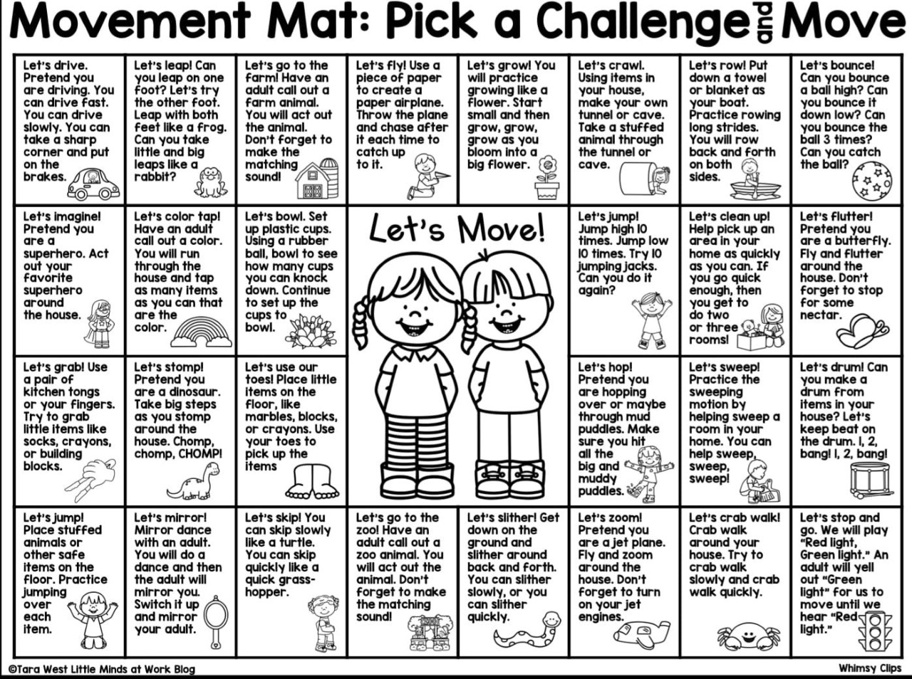

Just for Fun

***THIS or THAT***

**You can choose 1 or the other *or*  do both ☺**

**Zookeeper Game @DATL-Phys Ed on Twitter**

*Gather some stuffed animals and/or animal figures. Try to find some that* ***move differently****. A bear, a bunny, a dinosaur, a cat, a snake or lizard are all fun choices! If you don’t have any, your child can draw pictures of animals each on a separate sheet of paper. You will also need some items large enough to “hide” each figure. I’ve used plastic cups, empty planters, cardboard boxes, etc. In different area of the house, place one animal and cover it.*

*The first player is the Zookeeper. The Zookeeper goes to any hidden animal and places the animal on top of the covering and says what the animal is. All players then decide how to move like that animal. You can play music or use a timer for 20-30 seconds. Another player then becomes the Zookeeper and can pick another animal. Keep playing until you’ve visited all the animals!*

**THIS - Stairs in your house? Can you safely go up and down 10 times?**

**OR**

**THAT - PE Teacher Mr. C gives us a dance or exercise choice!**

<https://youtu.be/LybWBX1jaBg>

